CONFIGURING JENKINS

Contents

Download Jenkins 3

Documentation 3

Plugins 3

Getting Started 3

Starting Jenkins 3

Stopping Jenkins 3

Manage Jenkins 3

Basic Configuration 4

Tools Configuration 5

Configure Users 5

Use specific authorization 6

Configuring Job 7

Configuring Parameterized Job 7

Source Code Configuration 8

Build Triggers 9

Post Build Steps 10

Create Custom Views 10

# Download Jenkins

<https://jenkins.io/download/>

# Documentation

<https://jenkins.io/doc/>

# Plugins

<https://plugins.jenkins.io/>

# Getting Started

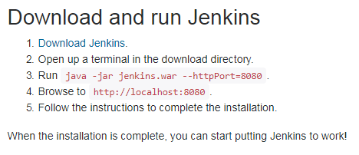

## Starting Jenkins

java –jar Jenkins.war –httpPort=8080

## Stopping Jenkins

Use Ctrl-C on the Jenkins command prompt window

## Manage Jenkins

We need to configure various properties of Jenkins before we start using it. Click on ‘Manage Jenkins’ to start configuring Jenkins.

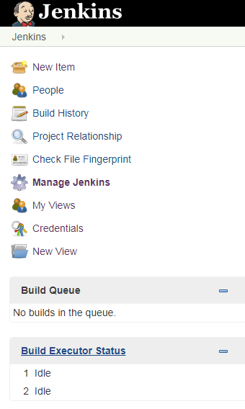

## Basic Configuration

Click on ‘Configure System’ to do basic configuration required for using Jenkins.

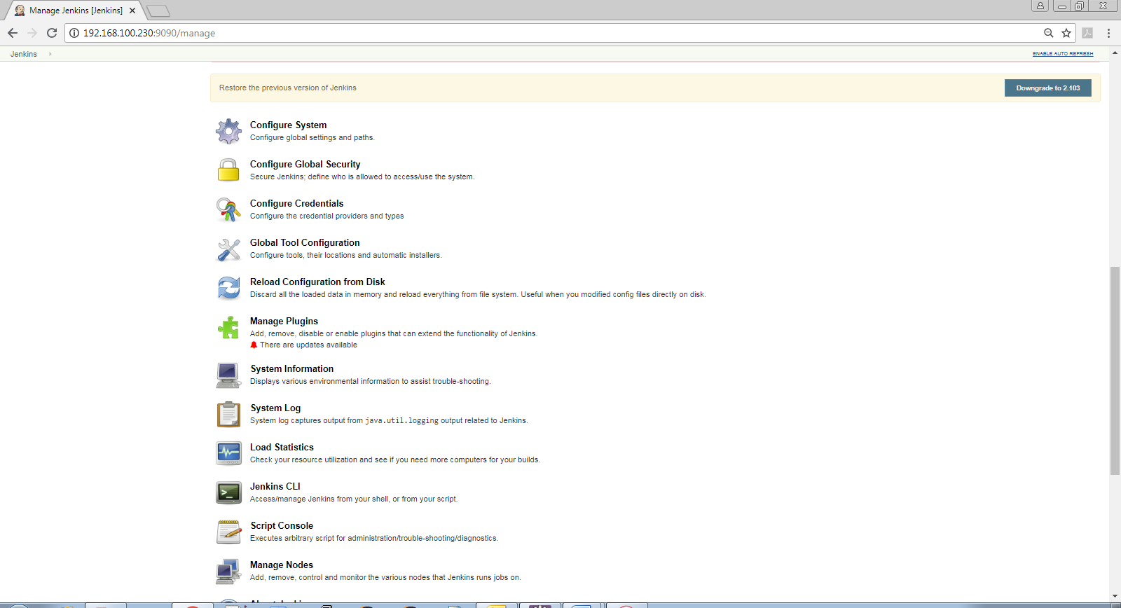

You would see following screen.

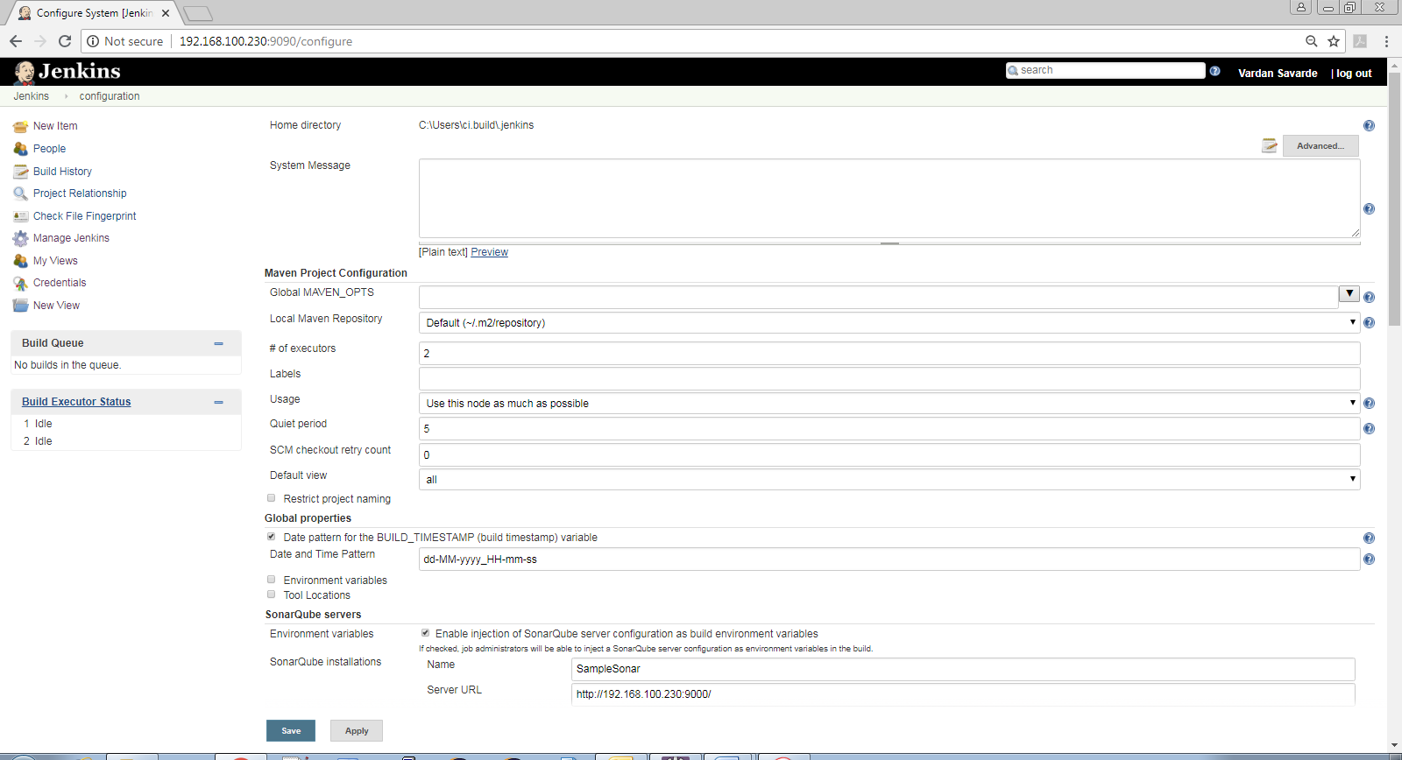

Click on ‘Advanced…’ to see advanced information

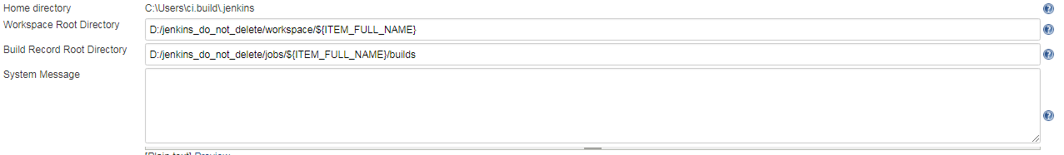

Home directory is when Jenkins basic configuration files would be available

Workspace Root directory is the workspace directory for Jenkins jobs. The source code checked out from version control systems is stored here temporarily.

Build Record Root Directory is where the Jenkins job related built information is kept.

The following screen configures the email notification sent out from Jenkins

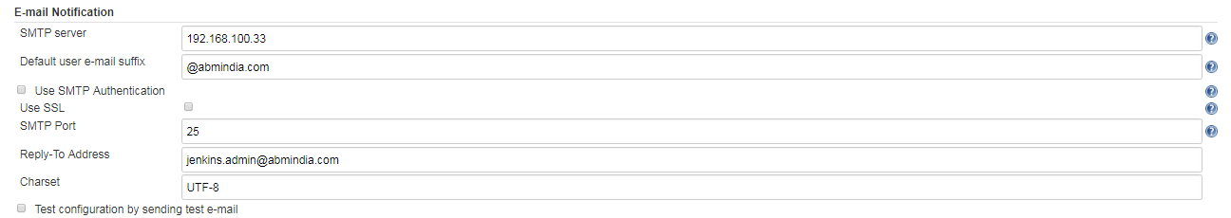

## Tools Configuration

Use ‘Configure System’ -> ‘Global Tool Configuration’ for configuring basic tools information for Jenkins to do its job. Here you can configure Ant, Maven, JDK related configuration.

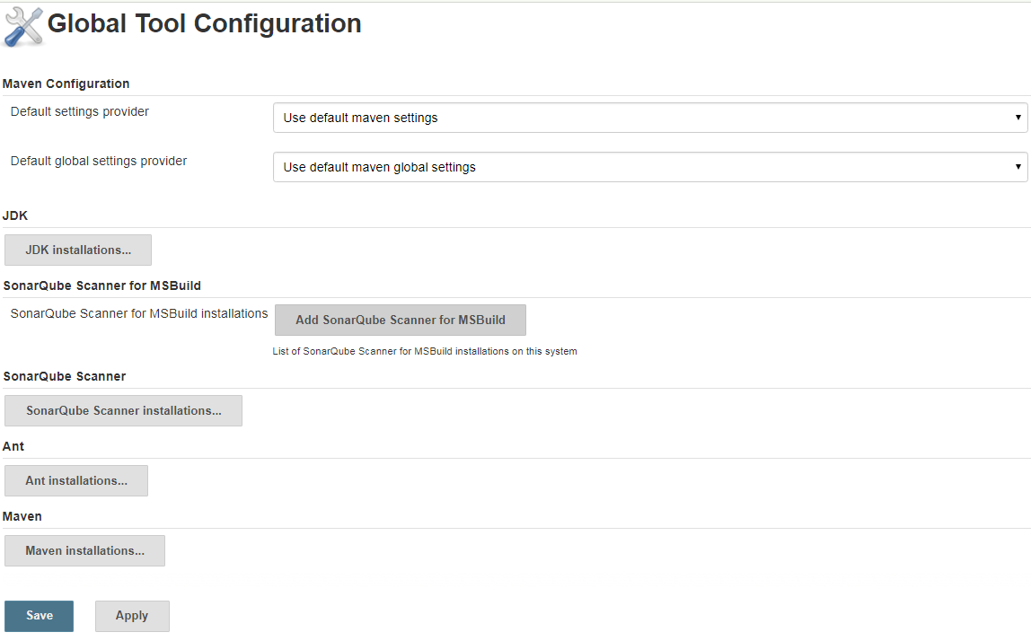

## Configure Users

Use ‘Configure System’ -> ‘Manage Users’ to create and manage users

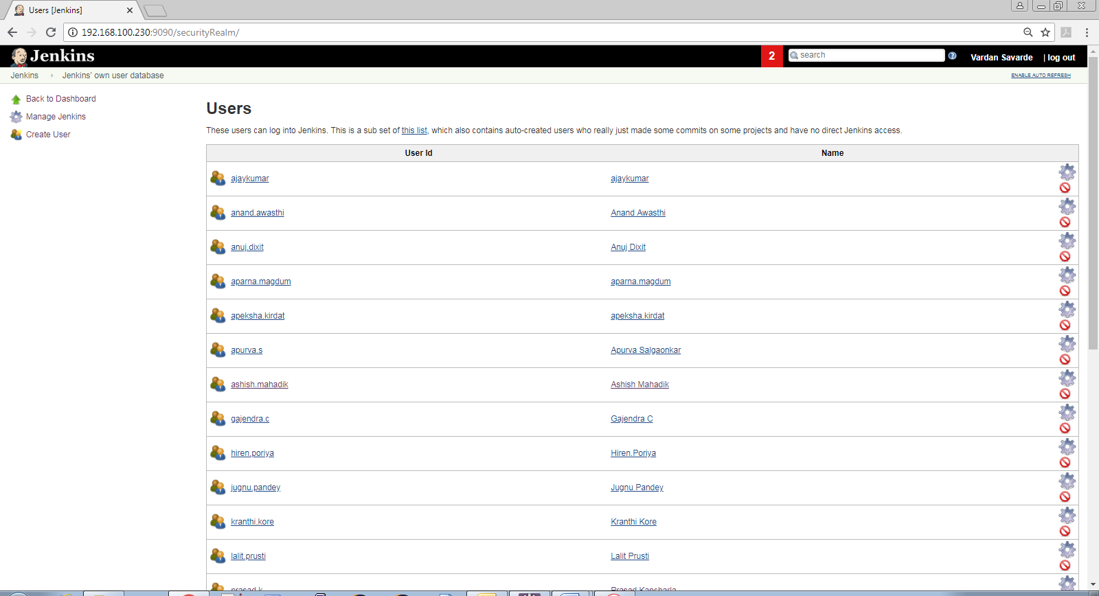

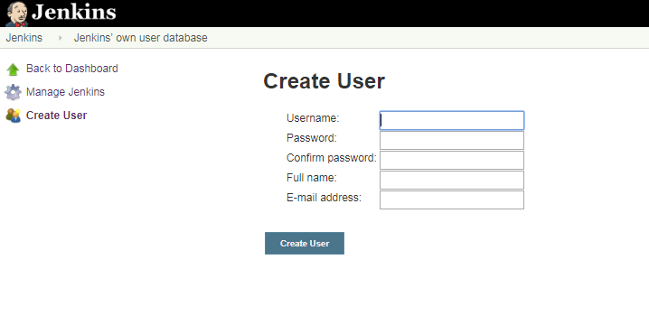

## Use specific authorization

Use ‘Configure System’ -> ‘Configure Global Security’ to configure user specific rights. Currently we are using ‘Project-based Matrix Authorization Strategy’

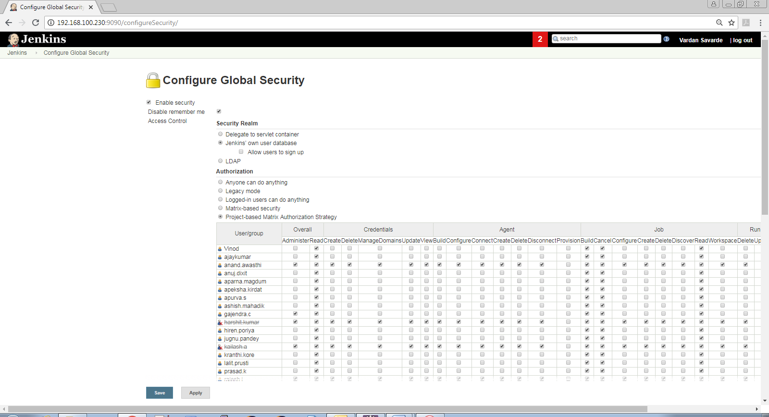

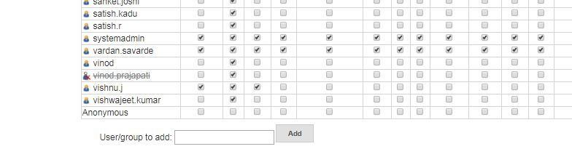

## Configuring Job

Use ‘New Item’ in left hand side navigation bar on ‘Configure System’ screen.

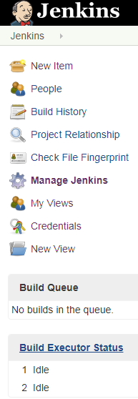

Enter the required details in the new job screen.

Select the appropriate project type. In our case we should select ‘Maven Project’

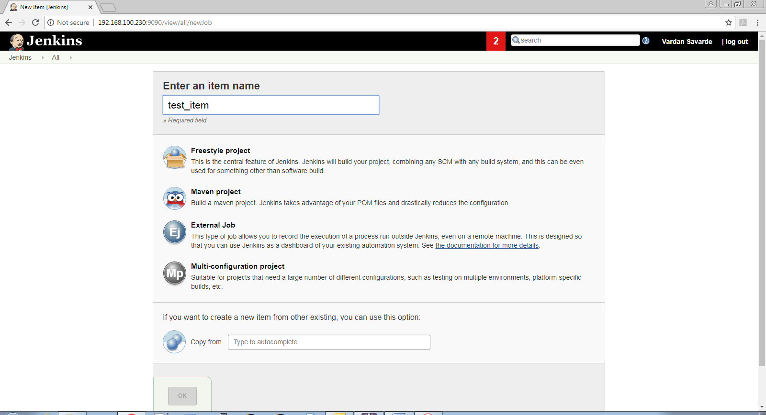

Once you enter the job name and select appropriate type, click on OK.

The following screen allows you to configure the job. Each field has ‘?’ against it. You can click on ‘?’ to get more information about that particular field.

### Configuring Parameterized Job

It is always better to create parameterized job.

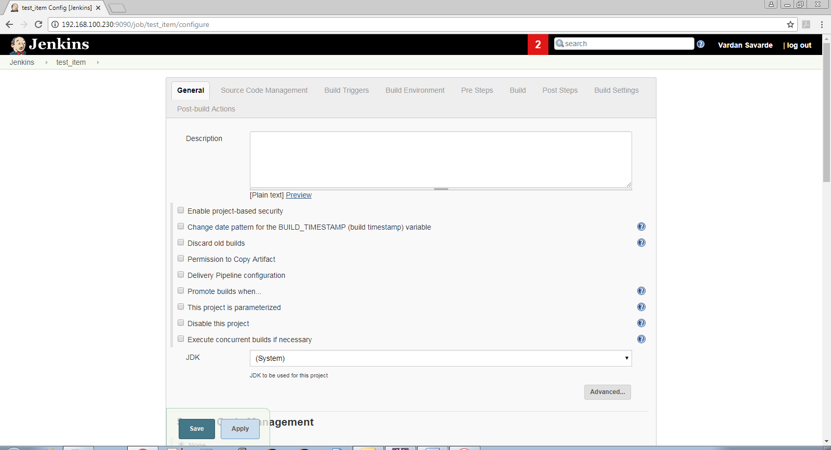

For example, in the following screen we have configured job which takes SVN tag name, server type as parameter

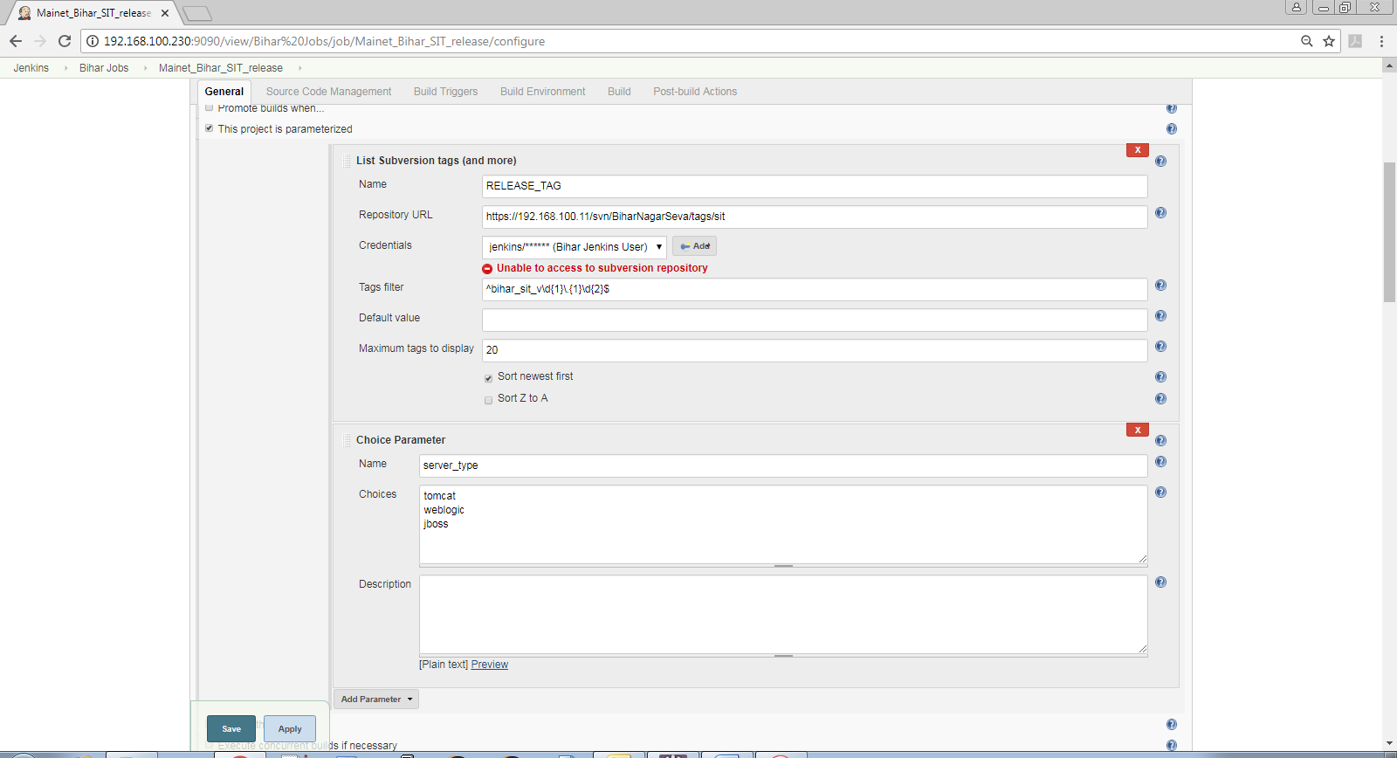

### Source Code Configuration

You can use the build parameters to configure the version control from where source needs to be used for the build. The following screen has sample.

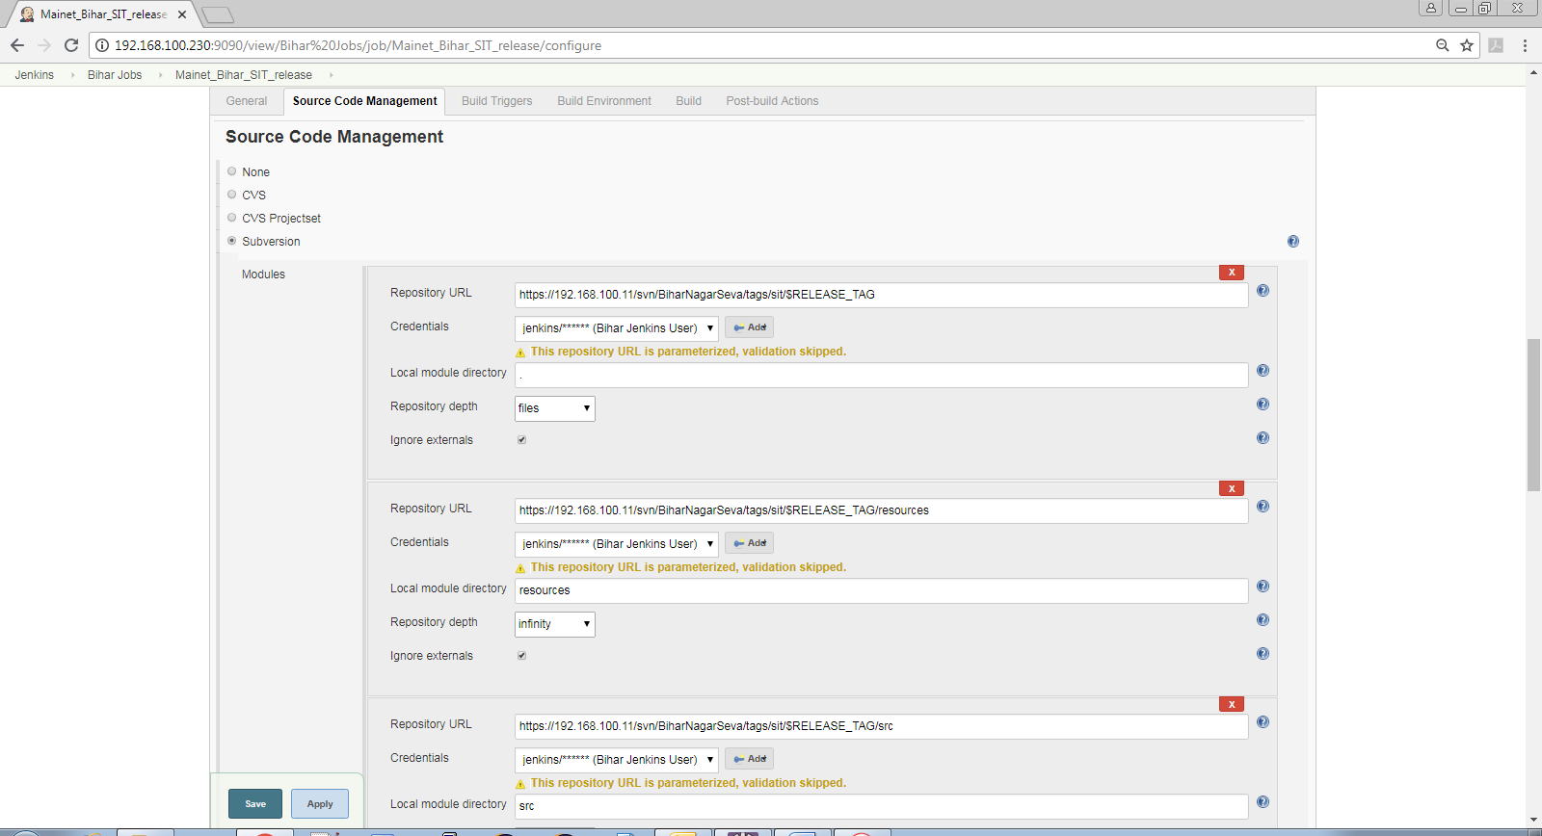

### Build Triggers

The ‘Build Triggers’ tab/section helps you configure when a particular build is triggered. If you want a build to be done manually, you should not select any of the options.

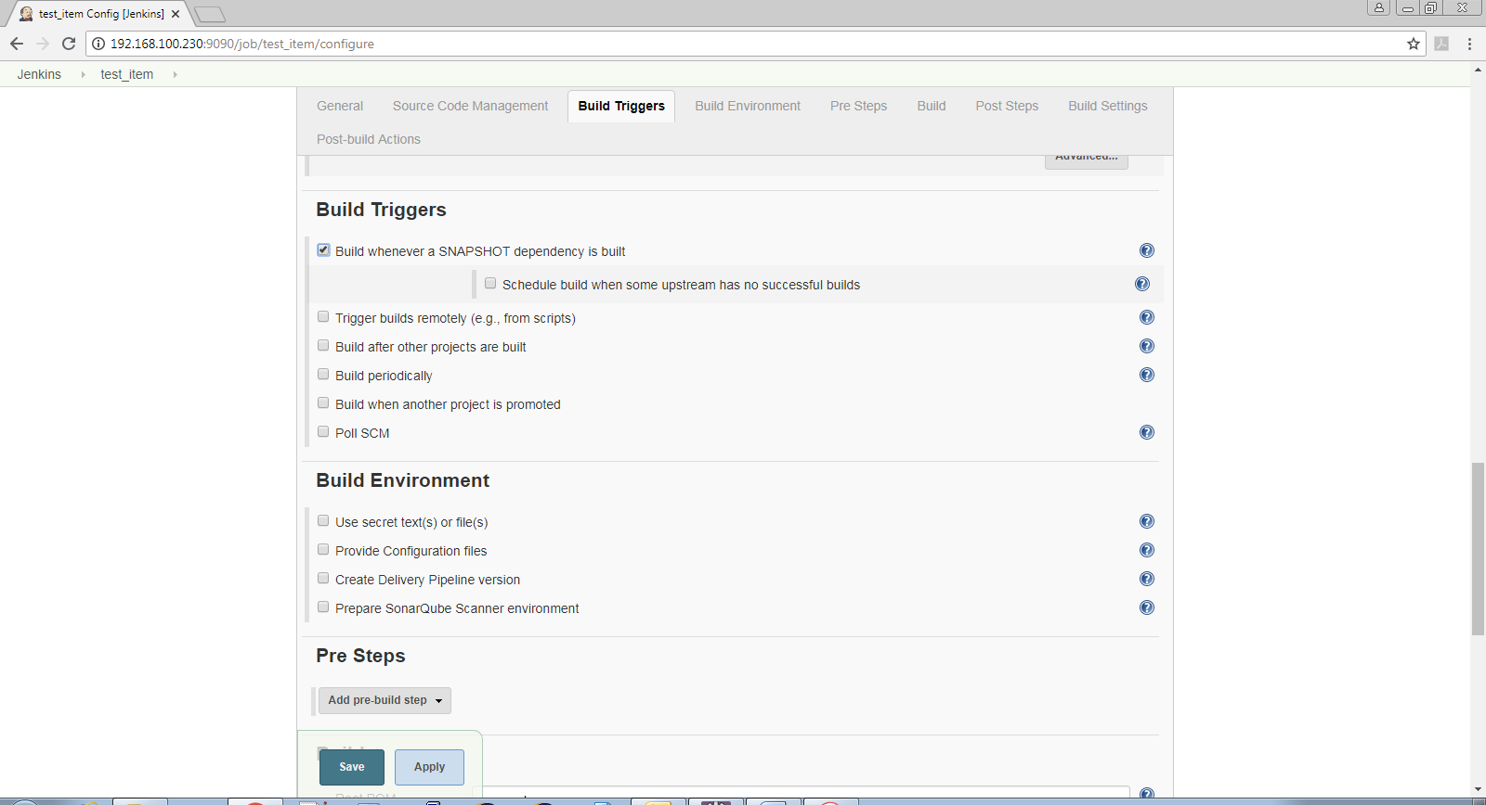

Configure the maven options in the Build section

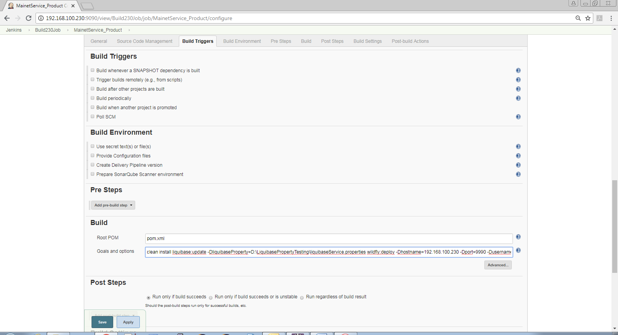

### Post Build Steps

Based on success/failure of the build, you can also configure the Post-Build action.

The following is example of tagging

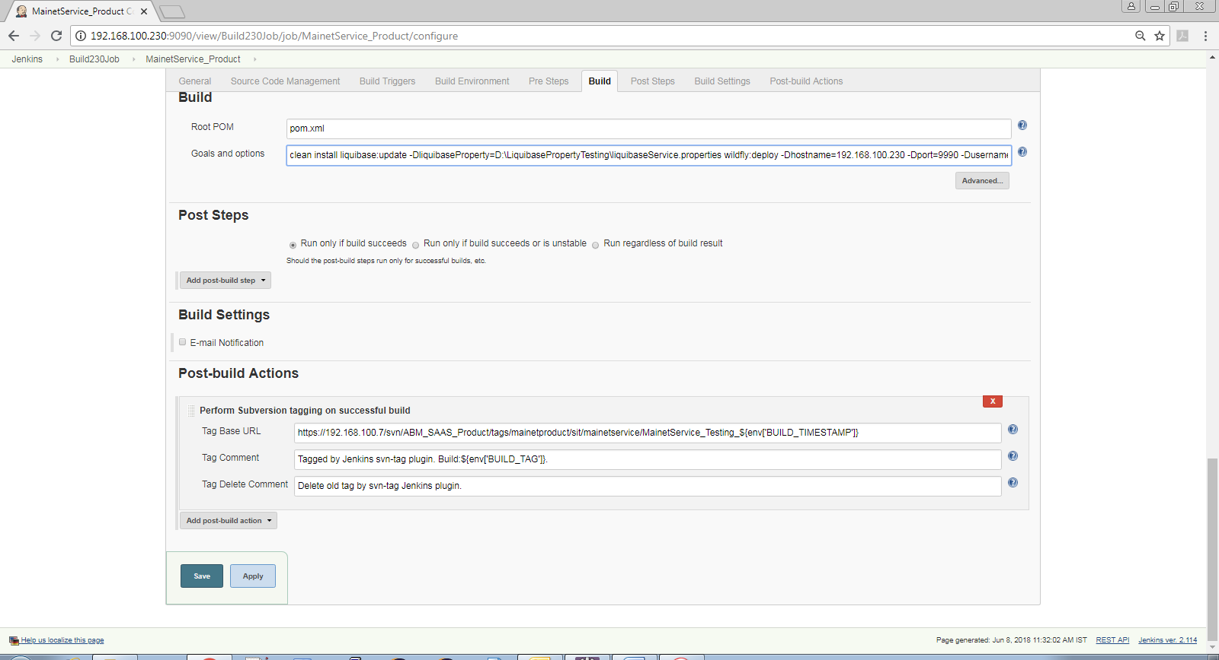

The following is example of artifact archiving.

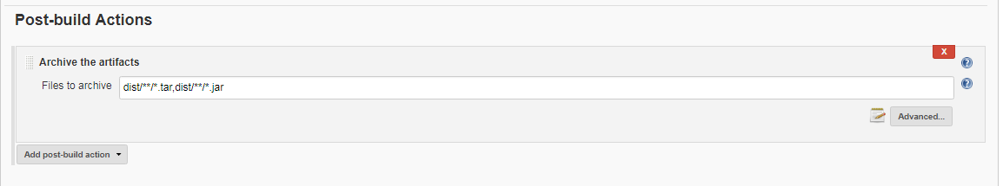

## Create Custom Views

Jenkins provides views which can be used to group various jobs so that similar jobs can be grouped together in the view.

